University of Canberra
Faculty of Science and Technology

Software Technology 2
(7170)
Week 10 Tutorial & Computer Lab

Phase 1: Data Structures Playground Core App with PyGame
Learning Objectives
- Review of DSA Foundations: Arrays/Lists, Basic Algorithms, Queues, Stacks, BFS/DFS
- Install PyGame for developing Data structures playground App
- Visual stack and queue interaction with push/pop/enqueue/dequeue buttons.
- Linked list editor: insert/delete/reverse with pointer visualization.
- Binary Search Tree visualizer: insert nodes, display traversal orders (in/pre/post).
Task 1: DSA Playground core App for Python Lists and Linear Search Algorithm Visualization
Objectives
- Review concepts of Python lists and basic iteration.
- Implement linear search and visualize the searching process step-by-step.
- Learn basic PyGame drawing (creating a grid, highlighting cells).
Key Concepts:
- Review of Python list operations: indexing, iteration. Linear search algorithm.
- PyGame window setup and drawing rectangles.
- In-Class Activity Demo:
  - Display a grid of numbers as rectangles on screen.
  - Highlight one cell at a time to simulate linear search.
  - Explain how search runs step-by-step visually.
Task_1_1.py: Class Activity for a simple DSA playground core with linear search (not assessed)
Challenge Task: Modify Task_1_1.py to enhance linear search visualisation(assessed as part of Assignment 2-Group Project)
#== task_1_1.py==
import pygame
import sys
import time

pygame.init()

WIDTH, HEIGHT = 600, 100
screen = pygame.display.set_mode((WIDTH, HEIGHT))
FONT = pygame.font.SysFont(None, 36)
clock = pygame.time.Clock()

numbers = [5, 3, 9, 1, 7, 4]
cell_width = WIDTH // len(numbers)

def draw_grid(highlight_index=None):
screen.fill((30, 30, 30))
for i, num in enumerate(numbers):
color = (200, 200, 200)
if i == highlight_index:
color = (255, 100, 100)
rect = pygame.Rect(i * cell_width, 0, cell_width - 2, HEIGHT)
pygame.draw.rect(screen, color, rect)
text = FONT.render(str(num), True, (0, 0, 0))
text_rect = text.get_rect(center=rect.center)
screen.blit(text, text_rect)

def linear_search(target):
for i, num in enumerate(numbers):
draw_grid(i)
pygame.display.flip()
if num == target:
return i
for event in pygame.event.get():
if event.type == pygame.QUIT:
pygame.quit()
sys.exit()
time.sleep(0.5)
return -1

def main():
target = 7
draw_grid()
pygame.display.flip()
time.sleep(1)

idx = linear_search(target)

draw_grid(idx)
pygame.display.flip()
time.sleep(2)

pygame.quit()

if __name__ == "__main__":
main()

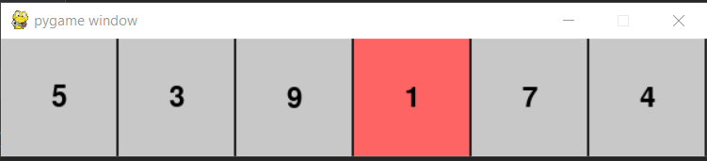

Task 1_1 Challenge Activity (to submit):
- Modify the linear search visualization to search for multiple target values one after another. Add a counter display that shows the number of comparisons done for each search.
- Allow user to input a target number via a simple keyboard input and then visualize the search.

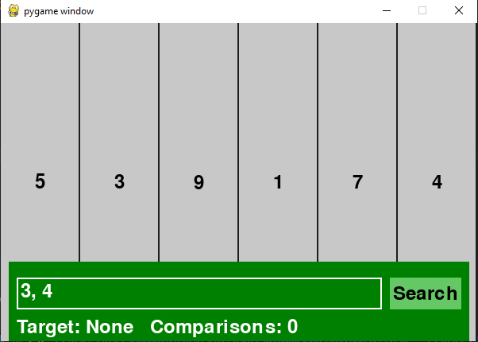

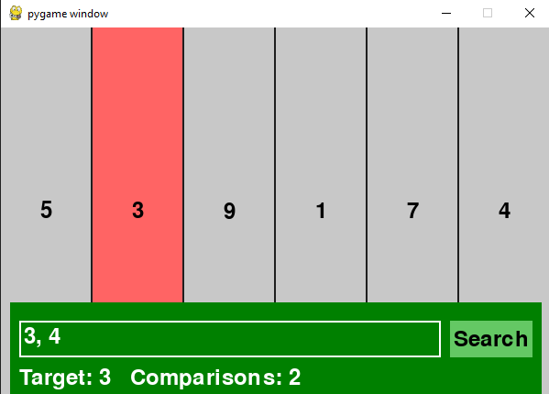
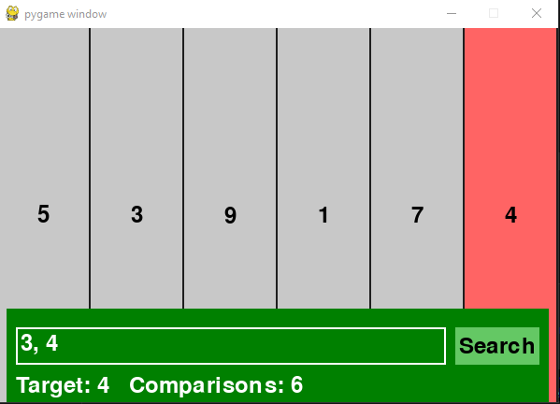

Task 1_2: Extending DSA Playground for Stacks and Queues with Visual Push/Pop Animations
Objectives
- Review queues (FIFO) and stacks (LIFO) operations and applications.
- Implement custom queue and stack classes in Python.
- Animate push/pop/enqueue/dequeue operations in PyGame.
Key Concepts
- Custom DSA Classes with methods for push, pop, enqueue, dequeue
- Visual representation as vertical bars or blocks moving in/out.
- Use event or timer-based animation in PyGame.
- Task_1_2.py: Class Activity for Visual stack where blocks are pushed or popped based on user keypress (e.g., space bar to push, backspace to pop).
- Challenge Task: Modify Task_1_2.py for a queue with enqueue/dequeue animations.

#==task_1_2.py==
import pygame
import sys

pygame.init()

WIDTH, HEIGHT = 300, 400
screen = pygame.display.set_mode((WIDTH, HEIGHT))
FONT = pygame.font.SysFont(None, 28)
clock = pygame.time.Clock()

stack = []

BLOCK_WIDTH, BLOCK_HEIGHT = 200, 40
START_X = (WIDTH - BLOCK_WIDTH) // 2
BASE_Y = HEIGHT - BLOCK_HEIGHT - 20

def draw_stack():
screen.fill((50, 50, 50))
for i, val in enumerate(stack):
rect = pygame.Rect(START_X, BASE_Y - i * (BLOCK_HEIGHT + 5), BLOCK_WIDTH, BLOCK_HEIGHT)
pygame.draw.rect(screen, (100, 150, 250), rect)
text = FONT.render(str(val), True, (0, 0, 0))
text_rect = text.get_rect(center=rect.center)
screen.blit(text, text_rect)
info_text = FONT.render("SPACE: Push, BACKSPACE: Pop, ESC: Quit", True, (200, 200, 200))
screen.blit(info_text, (10, 10))

def main():
counter = 1
running = True
while running:
for event in pygame.event.get():
if event.type == pygame.QUIT:
running = False
elif event.type == pygame.KEYDOWN:
if event.key == pygame.K_SPACE:
stack.append(counter)
counter += 1
elif event.key == pygame.K_BACKSPACE and stack:
stack.pop()
elif event.key == pygame.K_ESCAPE:
running = False

draw_stack()
pygame.display.flip()
clock.tick(30)

pygame.quit()

if __name__ == "__main__":
main()

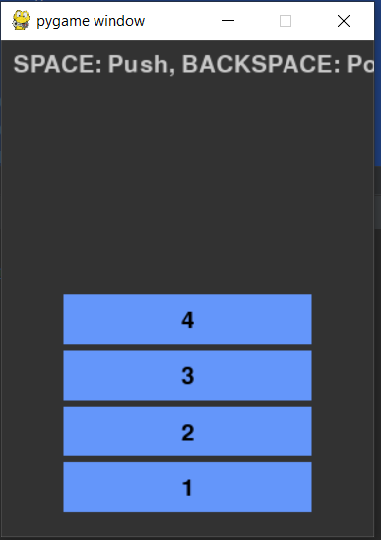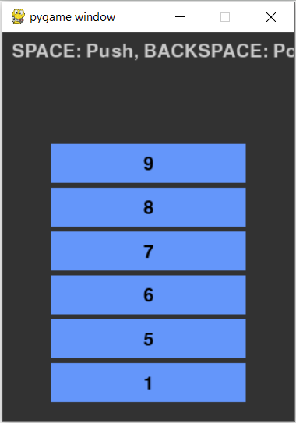
- (2)
- push data into stack with 4 space button presses
- push new data into stack after 4 pop operations (back space presses)

- Task 1_2 Challenge Activity (To submit):
Modify task_1_2.py to:
  - implement a queue visualization similar to the stack above.
  - Add buttons drawn on the screen to enqueue and dequeue elements (instead of keyboard controls).
  - Add animation where blocks slide in/out smoothly.

Task 1_3: Integrate all tasks in week 10 tutorial tasks (including challenge tasks) into DSA Explorer App - Phase 1
Objectives
- Refactor stack class and stack_visualier code from Task 1_2
- Implement PyGame DSA Explorer App- Phase 1 with stack visualisation
Key Concepts
- Custom Stack class with methods for push and pop,
- Visual representation as vertical bars or blocks moving in/out in stack visualiser
- Use event or timer-based animation in PyGame.
- Task_1_3.py: Class Activity for integrating Visual stack where blocks are pushed or popped based on user keypress (e.g., space bar to push, backspace to pop) with the DSA Visualiser - Phase 1
- Challenge Task: Modify Task_1_3.py for visualising queue data structure with enqueue/dequeue animations and integrate with DSA Visualiser- Phase 1 Requirements
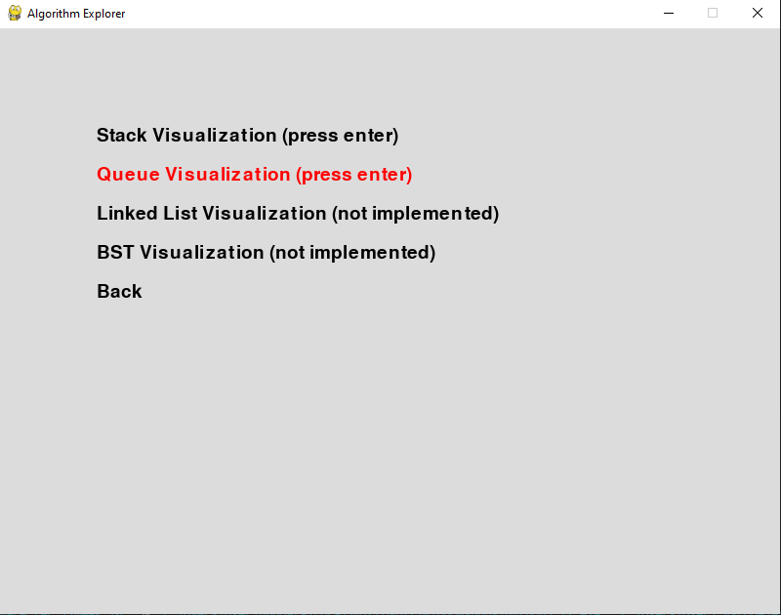

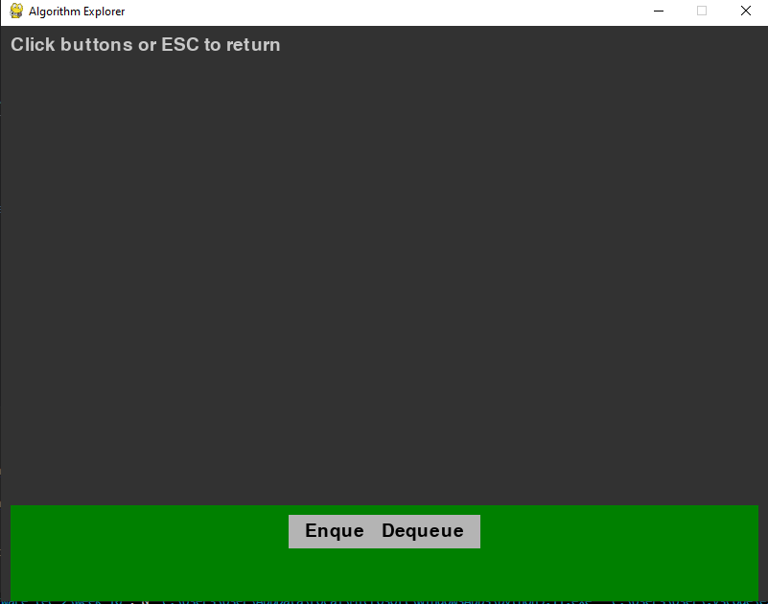

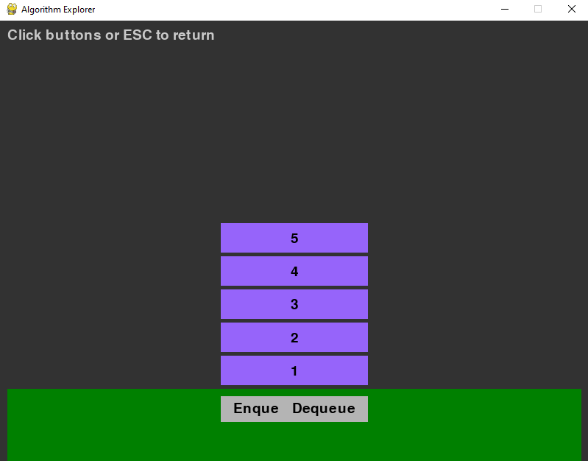
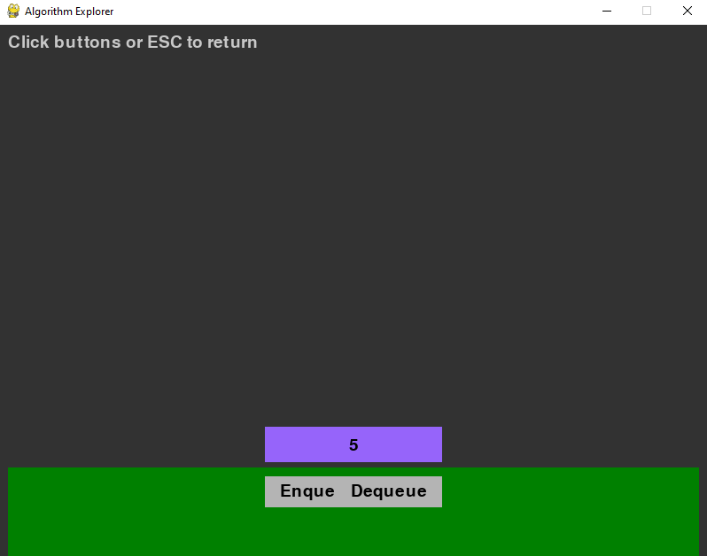

- Refactored Code Organisation for Task 1_3:

/project_root
/modules
stack.py
data_structures_visualiser.py
data_structures_tester.py

# modules/stack.py

class Stack:

def __init__(self):

self._data = []

def push(self, val):

self._data.append(val)

def pop(self):

if not self.is_empty():

return self._data.pop()

raise IndexError("pop from empty stack")

def peek(self):

if not self.is_empty():

return self._data[-1]

raise IndexError("peek from empty stack")

def is_empty(self):

return len(self._data) == 0

def size(self):

return len(self._data)

def __repr__(self):

return f"Stack({self._data})"

################################################
# modules/data_structures_visualiser.py
import pygame
import sys
from modules.stack import Stack

WIDTH, HEIGHT = 800, 600
clock = pygame.time.Clock()

BLOCK_WIDTH, BLOCK_HEIGHT = 200, 40
START_X = (WIDTH - BLOCK_WIDTH) // 2
BASE_Y = HEIGHT - BLOCK_HEIGHT - 20

def stack_visualization(screen, font):
stack = Stack()
counter = 1
running = True

while running:
for event in pygame.event.get():
if event.type == pygame.QUIT:
pygame.quit()
sys.exit()
elif event.type == pygame.KEYDOWN:
if event.key == pygame.K_SPACE:
stack.push(counter)
counter += 1
elif event.key == pygame.K_BACKSPACE and not stack.is_empty():
stack.pop()
elif event.key == pygame.K_ESCAPE:
running = False

screen.fill((50, 50, 50))
for i, val in enumerate(stack._data):
rect = pygame.Rect(START_X, BASE_Y - i * (BLOCK_HEIGHT + 5), BLOCK_WIDTH, BLOCK_HEIGHT)
pygame.draw.rect(screen, (100, 150, 250), rect)
text = font.render(str(val), True, (0, 0, 0))
text_rect = text.get_rect(center=rect.center)
screen.blit(text, text_rect)

info_text = font.render("SPACE: Push, BACKSPACE: Pop, ESC: Return to menu", True, (200, 200, 200))
screen.blit(info_text, (10, 10))

pygame.display.flip()
clock.tick(30)

def run(screen):
font = pygame.font.SysFont(None, 28)

menu_items = [
"Stack Visualization (press enter)",
"Queue Visualization (not implemented)",
"Linked List Visualization (not implemented)",
"BST Visualization (not implemented)",
"Back"
]
selected = 0
running = True
while running:
screen.fill((220, 220, 220))
for i, item in enumerate(menu_items):
color = (255, 0, 0) if i == selected else (0, 0, 0)
text = font.render(item, True, color)
screen.blit(text, (100, 100 + i * 40))

pygame.display.flip()

for event in pygame.event.get():
if event.type == pygame.QUIT:
pygame.quit()
sys.exit()
elif event.type == pygame.KEYDOWN:
if event.key == pygame.K_DOWN:
selected = (selected + 1) % len(menu_items)
elif event.key == pygame.K_UP:
selected = (selected - 1) % len(menu_items)
elif event.key == pygame.K_RETURN:
choice = menu_items[selected]
if choice == "Stack Visualization (press enter)":
stack_visualization(screen, font)
elif choice == "Back":
running = False

clock.tick(30)

###################################################################
# data_structures_tester.py
import pygame
import sys

pygame.init()

from modules import data_structures_visualiser

WIDTH, HEIGHT = 800, 600
screen = pygame.display.set_mode((WIDTH, HEIGHT))
pygame.display.set_caption("Algorithm Explorer")

FONT = pygame.font.SysFont(None, 36)
clock = pygame.time.Clock()

def draw_text(text, pos):
txt_surface = FONT.render(text, True, (0, 0, 0))
screen.blit(txt_surface, pos)

def main_menu():
screen.fill((200, 200, 250))
draw_text("Algorithm Explorer", (WIDTH // 3, 50))

buttons = {
'Data Structures': pygame.Rect(300, 150, 200, 50),
'Sorting': pygame.Rect(300, 230, 200, 50),
'Graphs': pygame.Rect(300, 310, 200, 50),
'Exit': pygame.Rect(300, 390, 200, 50),
}

for text, rect in buttons.items():
pygame.draw.rect(screen, (150, 150, 200), rect)
draw_text(text, (rect.x + 20, rect.y + 10))

pygame.display.flip()
return buttons

def main():
running = True
current_module = None

while running:
if current_module is None:
buttons = main_menu()

for event in pygame.event.get():
if event.type == pygame.QUIT:
running = False

elif event.type == pygame.MOUSEBUTTONDOWN:
pos = event.pos
for name, rect in buttons.items():
if rect.collidepoint(pos):
if name == "Exit":
running = False
elif name == "Data Structures":
current_module = name
else:
# Future modules here
pass

else:
try:
if current_module == "Data Structures":
data_structures_visualiser.run(screen)
# add other modules here as needed
except SystemExit:
running = False
break
finally:
current_module = None

clock.tick(30)

pygame.quit()
sys.exit()

if __name__ == "__main__":
main()

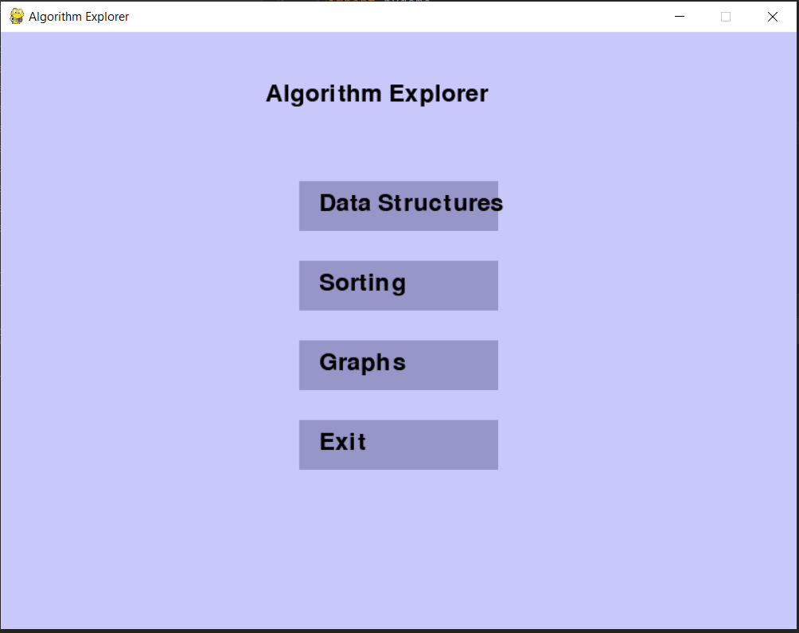
- Interface Menu after running the driver (data_structures_tester.py) for algorithm explorer app
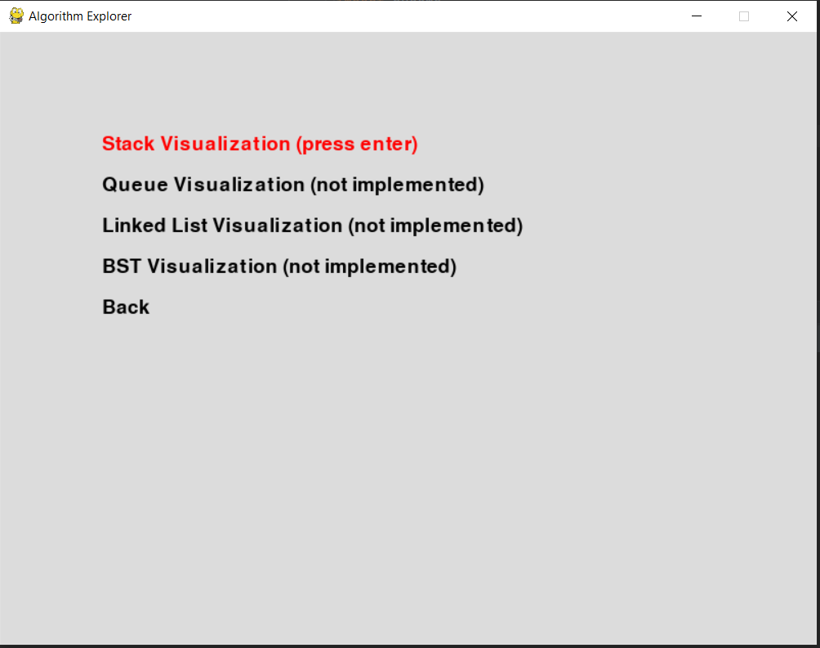
- Interface Menu after clicking on Data Structures button
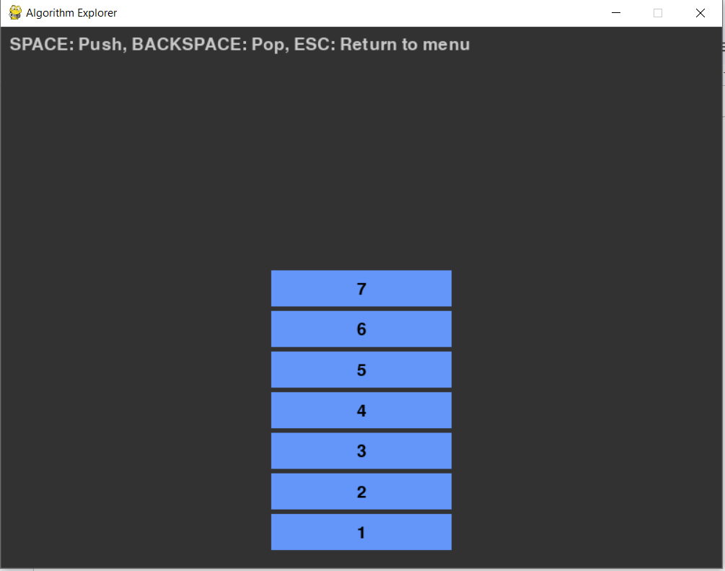
- Pressing the Stack Visualisation button and pushing data with space button in the stack
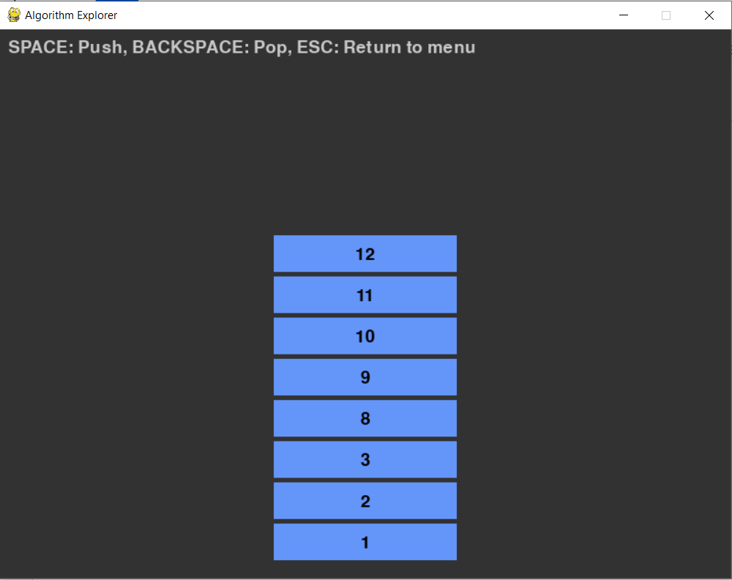
- popping data with backspace button and pushing data again with space button in the stack

Task 1_4: Implement Automated testing and benchmarking with Python Unit Test Module for integrated DSA explorer App-Phase 1
Objectives
- Implement Automated testing and benchmarking for stack class operations and extending the DSA explorer App - Phase 1
Key Concepts
- Custom Stack class with methods for push and pop,
- Implement Python Unit Tests for stack (push/pop) operations.
- Embed benchmarking of stack operations.
- Use event or timer-based animation in PyGame.
- Task_1_4.py: Class Activity for implementing Python unit tests for stack operations and extending it for performance benchmarking for integrated DSA Explorer App.
- Challenge Task: Modify Task_1_4.py for testing queue implementation with enqueue/dequeue animations and integrate with DSA Visualiser- Phase 1 Requirements

- Refactored Code Organisation for Task 1_4:

/project_root
/modules
stack.py
data_structures_visualiser.py
data_structures_tester.py
/tests
test_stack.py

# tests/test_stack.py

import unittest

import time

from modules.stack import Stack

class TestStack(unittest.TestCase):

def test_push_pop(self):

s = Stack()

for i in range(1000):

s.push(i)

self.assertEqual(s.size(), 1000)

for i in reversed(range(1000)):

v = s.pop()

self.assertEqual(v, i)

self.assertTrue(s.is_empty())

def test_peek_and_exceptions(self):

s = Stack()

with self.assertRaises(IndexError):

s.pop()

with self.assertRaises(IndexError):

s.peek()

s.push(42)

self.assertEqual(s.peek(), 42)

self.assertEqual(s.size(), 1)

def test_benchmark(self):

s = Stack()

start = time.time()

n = 10**6

for i in range(n):

s.push(i)

for i in range(n):

s.pop()

end = time.time()

elapsed = end - start

print(f"Benchmark push/pop {n} items: {elapsed:.4f} seconds")

if __name__ == "__main__":

unittest.main()

###############################################

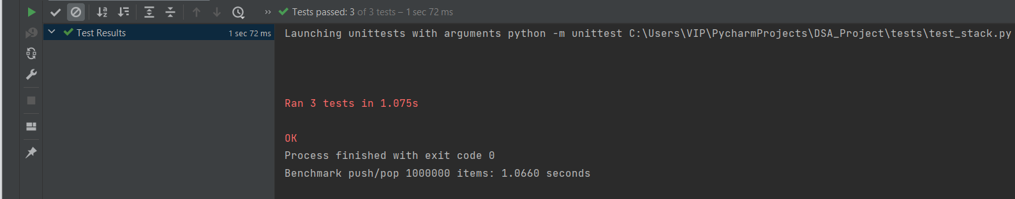
- Testing with n = 10**6 in test_benchmark method in test_stack.py
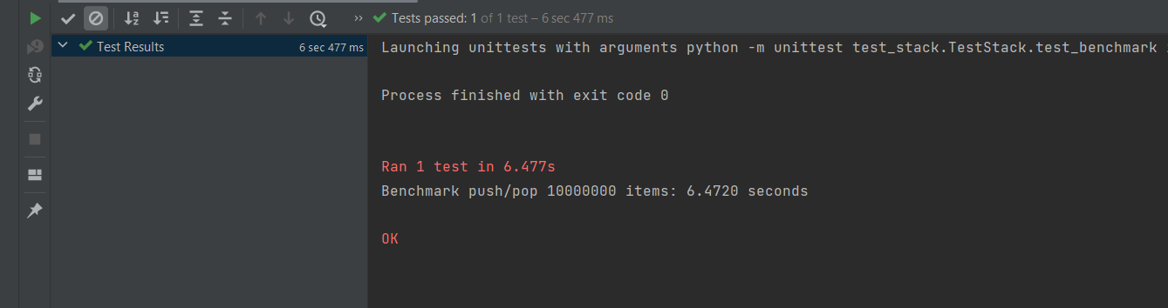
- Testing with n = 10**7 in test_benchmark method in test_stack.py

###############################################

GitHub Submission requirements for Assignment 2-Group Project aligned with Week 10 tutorial tasks
Phase 1 Tasks | Tasks for learning  All Class Activities | Tasks for Submission  All Challenge Activities
1.1 | A simple DSA playground core setup with linear search using Pygame | - Modify the linear search visualization to search for multiple target values one after another. Add a counter display that shows the number of comparisons done for each search.  - Allow user to input a target number via a simple keyboard input and then visualize the search.
1.2 | Visual stack where blocks are pushed or popped based on user keypress (e.g., space bar to push, backspace to pop). | - implement a queue visualization similar to the stack.  - Add buttons drawn on the screen to enqueue and dequeue elements (instead of keyboard controls).  - Add animation where blocks slide in/out smoothly.
1.3 | Refactor and Integrate stack visualiser code into DSA Explorer App - Phase 1 | - Refactor and Integrate queue visualiser code into DSA Explorer App - Phase 1
1.4 | Implement automated testing and benchmarking for stack operations - integrated into DSA Explorer App - Phase 1 | - Implement automated testing and benchmarking for queue operations - integrated into DSA Explorer App - Phase 1

##############################################################################

